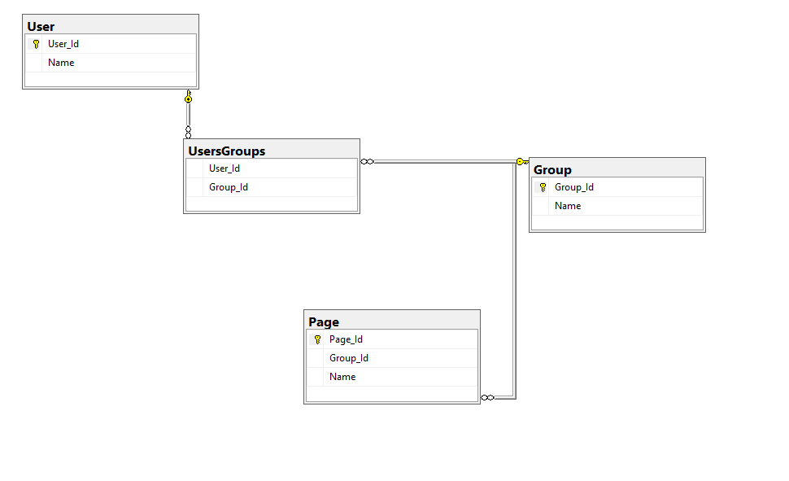

SQL Query

SELECT

Page.Name

FROM

Page

INNER JOIN [Group] on [Group].Group_Id = Page.Group_Id

INNER JOIN UsersGroups on UsersGroups.Group_Id= Page.Group_Id

WHERE

UsersGroups.User_Id =3